**Exercise 3: Assertions in Junit**

**AssertionsTest.java :-**

package org.example1;  
  
import org.junit.Test;  
import static org.junit.Assert.*;  
  
public class AssertionsTest {  
  
 @Test  
 public void testAssertEquals() {  
 *assertEquals*("Sum should be 5", 5, 2 + 3);  
 }  
  
 @Test  
 public void testAssertTrue() {  
 *assertTrue*("Expected condition to be true", 5 > 3);  
 }  
  
 @Test  
 public void testAssertFalse() {  
 *assertFalse*("Expected condition to be false", 5 < 3);  
 }  
  
 @Test  
 public void testAssertNull() {  
 Object obj = null;  
 *assertNull*("Object should be null", obj);  
 }  
  
 @Test  
 public void testAssertNotNull() {  
 Object obj = new Object();  
 *assertNotNull*("Object should not be null", obj);  
 }  
}

**pom.xml :-**

<project xmlns="http://maven.apache.org/POM/4.0.0" xmlns:xsi="http://www.w3.org/2001/XMLSchema-instance"  
 xsi:schemaLocation="http://maven.apache.org/POM/4.0.0 http://maven.apache.org/xsd/maven-4.0.0.xsd">  
 <modelVersion>4.0.0</modelVersion>  
  
 <groupId>org.example1</groupId>  
 <artifactId>Assertions</artifactId>  
 <version>1.0-SNAPSHOT</version>  
 <packaging>jar</packaging>  
  
 <name>Assertions</name>  
 <url>http://maven.apache.org</url>  
  
 <properties>  
 <project.build.sourceEncoding>UTF-8</project.build.sourceEncoding>  
 </properties>  
  
 <dependencies>  
 <dependency>  
 <groupId>junit</groupId>  
 <artifactId>junit</artifactId>  
 <version>3.8.1</version>  
 <scope>test</scope>  
 </dependency>  
 <dependency>  
 <groupId>junit</groupId>  
 <artifactId>junit</artifactId>  
 <version>4.13.2</version>  
 <scope>test</scope>  
 </dependency>  
 </dependencies>  
</project>

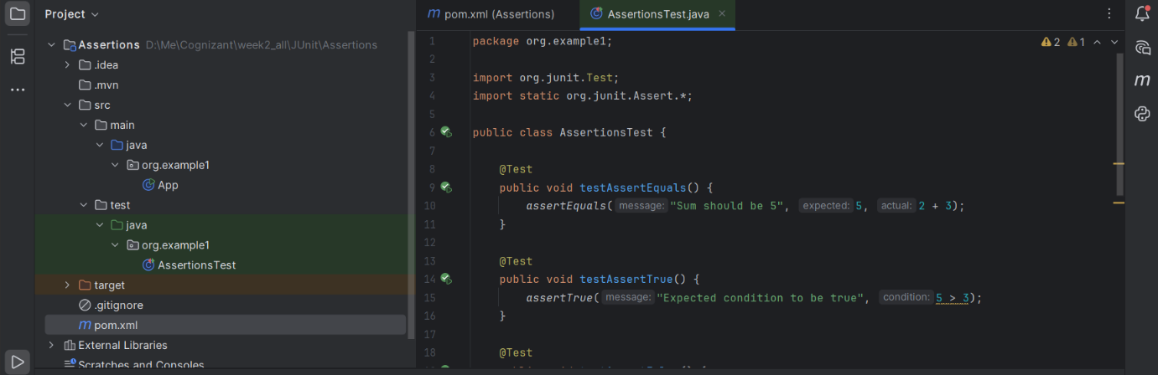

**Output :-**

